
TEMASEK JUNIOR COLLEGE

CHEMISTRY 8872/01
Paper 1 Multiple Choice

Tuesday 21st SEPTEMBER 2010 50 minutes

Additional materials: Data Booklet
Multiple Choice Answer Sheet

READ THESE INSTRUCTIONS FIRST

Do not open this booklet until you are told to do so.

Write in soft pencil.
Do not use staples, paper clips, highlighters, glue or correction fluid.
Write your name, index number and CG on the Answer Sheet in the spaces provided.

There are thirty questions on this paper. Answer all questions. For each question, there are four possible answers labelled A, B, C, and D.
Choose the one you consider correct and record your choice in soft pencil on the separate Answer Sheet.

Read the instructions on the Answer Sheet very carefully.

Each correct answer will score one mark. A mark will not be deducted for a wrong answer.
Any rough working should be done in this booklet.
You may use a calculator.

Section A
For each question there are four possible answers, A, B, C and D. Choose the one you consider to be correct.
1 | Boron consists of the isotopes 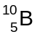 and 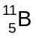. In an experiment, the relative abundance of atoms in the isotopic mixture is found to be 60%. What is the relative atomic mass of boron based on the experiment?
 | A |  | 10.2 |  |  |  |  | B |  |  |  |  |  | 10.4 |  |  |  | C |  |  |  | 10.5 |  |  |  |  | D |  |  |  |  | 10.6
2 | Which of the following formulae represents a particle with the composition 1 proton, 1 neutron and 2 electrons?  (D represents deuterium, ²H)
 | A |  | D |  |  |  |  | B |  |  |  |  |  | D⁻ |  |  |  | C |  |  |  | H⁻ |  |  |  |  | D |  |  |  |  | He
3 | Oxygen reacts with platinum (VI) fluoride, PtF₆, as follows:  O₂ + PtF₆ O₂⁺ PtF₆⁻  It was suggested that xenon should react similarly and, in this way, the first noble gas compound was produced.  Xe + PtF₆ Xe⁺ PtF₆⁻  What is the most likely reason for the suggestion being made?
 | A |  |  | O and Xe have similar atomic radii.
 | B |  |  | O and Xe have similar atomic affinities.
 | C |  |  | O and Xe have similar electronic configurations.
 | D |  |  | O₂ and Xe have similar first ionisation energies.
4 | Which graph represents the number of unpaired p orbital electrons for atoms with proton numbers 13 to 18?  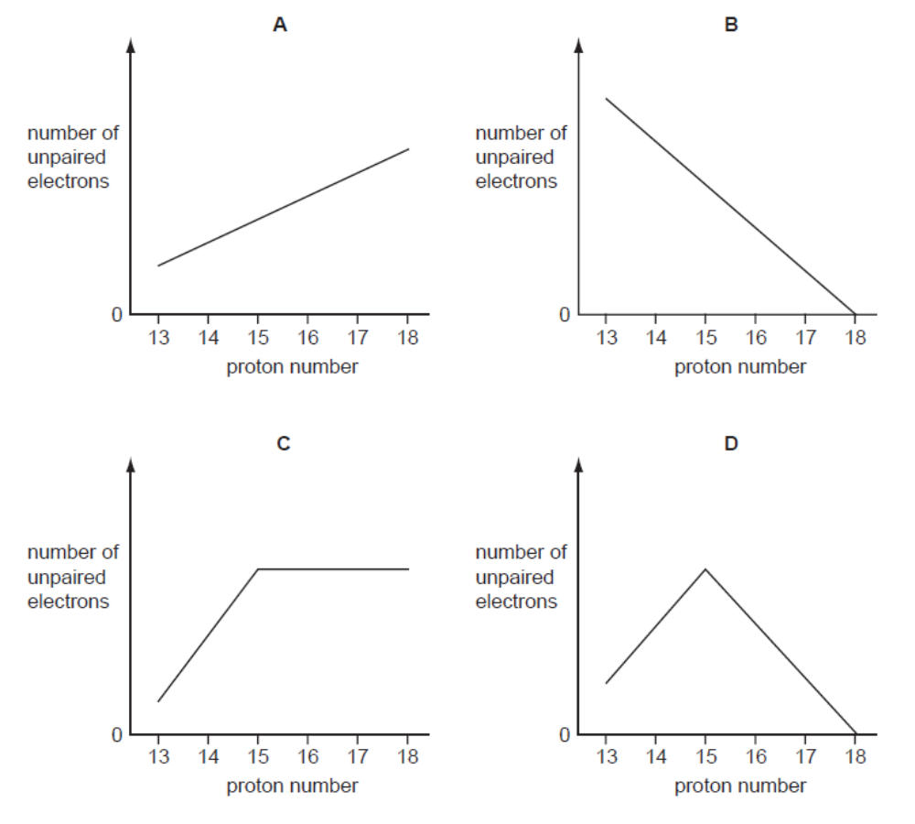  A  B  C  D
5 | Which one of the following is the correct shape of hydroxylamine, 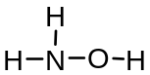?  About N About O
 | A |  |  | Trigonal pyramidal Bent
 | B |  |  | Trigonal pyramidal Linear
 | C |  |  | Trigonal planar Linear
 | D |  |  | Trigonal planar Bent
6 | Which of the following pairs contains delocalized electrons in both systems?
 | A |  |  | cyclohexene, sodium
 | B |  |  | sodium, graphite
 | C |  |  | graphite, silicon
 | D |  |  | benzene, ethene
7 | Which of the following statements is correct?
 | A |  |  | XeF₄ and CH₃CH=CH₂ are planar molecules
 | B |  |  | BCl₃ and BrCl₃ have the same molecular shape.
 | C |  |  | Benzene and ethanol are non–polar liquids.
 | D |  |  | AlH₄⁻ and BF₄⁻ contain dative covalent bonds.
8 | The boiling points of ammonia, hydrogen chloride and carbon dioxide are given below.  Which of the following statements best explains the above data?
  Gas | Formula | Boiling point / ºC
  ammonia | NH₃ | –33
  hydrogen chloride | HCl | –85
  carbon dioxide | CO₂ | –78
 | A |  |  | NH₃ has a higher boiling point than HCl because the hydrogen bonding in NH₃ is stronger than the permanent dipole–permanent dipole interactions in HCl.
 | B |  |  | The strength of the induced dipole–induced dipole interactions increases in the order HCl < CO₂ < NH₃.
 | C |  |  | The strength of the permanent dipole–permanent dipole interactions increases in the order HCl < CO₂ < NH₃.
 | D |  |  | CO₂ has a higher boiling point than HCl because the permanent dipole–permanent dipole interactions in CO₂ are stronger than the permanent dipole–permanent dipole interactions in HCl.
9 | Three substances, R, S, T, have physical properties as shown.  What could be the identities of R, S and T?
  Substance | mp/ºC | bp/ºC | Electrical conductivity
  Substance | mp/ºC | bp/ºC | of solid | of liquid
  R | 801 | 1413 | poor | good
  S | 2852 | 3600 | poor | good
  T | 3550 | 4827 | good | not known
 |  |  |  | R |  |  |  |  |  | S |  |  |  |  |  |  |  |  |  | T
 | A |  |  | NaF |  |  |  |  |  | KCl |  |  |  |  |  |  |  |  |  | Cu
 | B |  |  | NaBr |  |  |  |  |  | BaO |  |  |  |  |  |  |  |  |  | SiO₂
 | C |  |  | NaCl |  |  |  |  |  | MgO |  |  |  |  |  |  |  |  |  | C[graphite]
 | D |  |  | NaBr |  |  |  |  |  | CaO |  |  |  |  |  |  |  |  |  | C[diamond]
10 | 10 cm³ of 0.2 mol dm⁻³ K₂XO₄ will just react with 40 cm³ of 0.1 mol dm⁻³ iron(II) sulfate solution.  If Fe²⁺ is oxidized to Fe³⁺ by K₂XO₄, what is the final oxidation state of X?
 | A |  | +2 |  |  |  |  | B |  |  |  |  |  | +3 |  |  |  | C |  |  |  | +4 |  |  |  |  | D |  |  |  |  | +5
11 | 2CHClF₂ (g) CF₂=CF₂ (g) + 2HCl (g)  The standard enthalpy changes of formation of HCl (g) is -92.3 kJ mol⁻¹, that of CHClF₂ (g) is -485.2 kJ mol⁻¹ and that of CF₂=CF₂ (g) is -658.3 kJ mol⁻¹.  Which of the following describes how the yield of CF₂=CF₂ (g) at equilibrium varies as temperature increases?
A B
Yield
temperature
Yield

temperature

C D
Yield
temperature
Yield

temperature

12 | 20 cm³ of 0.10 mol dm⁻³ of aqueous NaOH is added to 25 cm³ of 0.15 mol dm⁻³ of hydrochloric acid.  What is the approximate pH of the final solution?
 | A |  |  | 1.4 |  |  | B |  |  |  |  | 2.8 |  |  |  |  |  | C |  |  |  |  | 4.5 |  |  |  | D |  |  |  | 7.0
13 | The graph shows the change in pH when ethanoic acid is gradually added to 10 cm³ of 0.10 mol dm⁻³ sodium hydroxide. An indicator is used to determine the end-point for the titration.  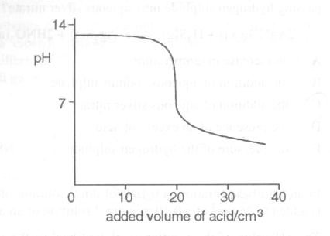  Which of the following contains the correct concentration of ethanoic acid and indicator used for the titration?
 | A |  |  | 0.05 mol dm⁻³ ethanoic acid, screened methyl orange
 | B |  |  | 0.05 mol dm⁻³ ethanoic acid, phenolphthalein
 | C |  |  | 0.10 mol dm⁻³ ethanoic acid, screened methyl orange
 | D |  |  | 0.10 mol dm⁻³ ethanoic acid, phenolphthalein
14 | Iodine-131 is a radioactive isotope with a half-life of 8 days.  Given that radioactive decay is a first-order reaction, what fraction of the isotope would remain after 48 days?
 | A |  |  | 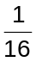 |  |  | B |  |  |  | 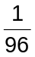 |  |  |  |  |  | C |  |  |  | 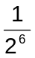 |  |  |  |  | D |  |  |  | 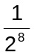
15 | Hydrogen peroxide reacts with acidified iodide ions, liberating iodine. In investigations of this reaction, the following results were obtained.  Which of the following statements follows from these results?
  initial concentration of reactants/ mol dm⁻³ |  |  | initial rate of formation of iodine/ mol dm⁻³ s⁻¹
  [H₂O₂] | [I⁻] | [H⁺] | initial rate of formation of iodine/ mol dm⁻³ s⁻¹
  0.010  0.030  0.030  0.030 | 0.010  0.010  0.020  0.020 | 0.10  0.10  0.10  0.20 | 2 x 10⁻⁶  6 x 10⁻⁶  1.2 x 10⁻⁵  1.2 x 10⁻⁵
 | A |  |  | The overall order of this reaction is 2.
 | B |  |  | The unit of the rate constant k is mol⁻² dm⁶ s⁻¹.
 | C |  |  | This reaction can be catalysed by H⁺.
 | D |  |  | The rate equation for the reaction can be written as rate = k [H₂O₂]² [I⁻]
16 | The chloride of an element R of the third period is a liquid which has a boiling point of 76 °C and fumes in air.  After mixing 0.010 mol of the chloride with water, the resulting solution required 100 cm³ of 0.30 mol dm⁻³ silver nitrate for complete precipitation of the chloride ion.  To which Group of the Periodic Table does R belong?
 | A |  |  | I |  | B |  |  | III |  |  |  |  |  | C |  |  |  | IV |  |  |  |  | D |  |  |  |  | V
17 | The graph shows how a property of the elements Na to Cl varies with proton number.  11  12  13  14  15  16  17  Proton number  What is the property?
 | A |  |  | ionic radius
 | B |  |  | first ionisation energy
 | C |  |  | melting point
 | D |  |  | electronegativity
18 | Which of the following synthetic routes does not produce ethanoic acid?
 | A
 | B
 | C |  |  | 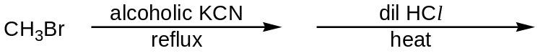
 | D |  |  | 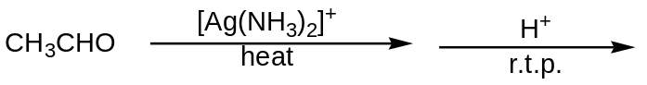
19 | 1,2-dibromo-3-chloropropane (DBCP) has been used in the control of earthworms in agricultural land. Which of the following would be the best synthesis of this compound?
 | A |  |  | CH₃CH₂CH₂Cl + 2Br₂ → DBCP + 2HBr
 | B |  |  | CH₂BrCHBrCH₃ + Cl₂ → DBCP + HCl
 | C |  |  | ClCH₂CH=CH₂ + PBr₅ → DBCP + PBr₃
 | D |  |  | CH₂=CHCH₂Cl + Br₂ → DBCP
20 | In the hydrogenation of HO₂C-CH₂-CH=CH-CHO using platinum catalyst, the volume of hydrogen (measured at s.t.p.) that reacts with 1 mole of the compound could be
 | A |  |  | 22.4 dm³ |  |  |  | B |  |  |  |  | 24.0 dm³ |  |  | C |  |  |  | 44.8 dm³ |  |  |  |  | D |  |  |  |  | 67.2 dm³
21 | The ester X, which is used in perfumes, has the molecular formula C₆H₁₂O₂. It is found that one of the products of acid hydrolysis of compound X gives a yellow precipitate with hot aqueous alkaline iodine.  What is the structural formula of compound X?
 | A |  |  |  | CH₃CO₂CH₂CH(CH₃)₂
 | B |  |  |  | (CH₃)₂CHCO₂CH₂CH₃
 | C |  |  |  | CH₃CH₂CO₂CH₂CH₂CH₃
 | D |  |  |  | CH₃CH₂CH(CH₃)CO₂CH₃
22 | When an organic compound X was treated with phosphorous pentachloride, fumes of hydrogen chloride were evolved. When X was warmed with acidified aqueous potassium dichromate(VI), the solution turned green.  Which of the following was X?
 | A |  |  | CH₃CH₂CHO
 | B |  |  | CH₃CH(OH)CH₃
 | C |  |  | CH₃CH₂CO₂H
 | D |  |  | CH₃COCH₃
23 | Which one of the following gives the correct order of acid strength (strongest first) for ethanoic acid, chloroethanoic acid, and ethyl ethanoate?
   | Strongest Weakest
  A | ethanoic acid | chloroethanoic acid | ethyl ethanoate
  B | chloroethanoic acid | ethyl ethanoate | ethanoic acid
  C | chloroethanoic acid | ethanoic acid | ethyl ethanoate
  D | ethyl ethanoate | chloroethanoic acid | ethanoic acid
24 | Bromine in an inert solvent is added separately to hexane, hexene, benzene and methylbenzene. In which of the following pairs will the observations be the same?
 | A |  |  | Hexane and benzene
 | B |  |  | Hexane and hexene
 | C |  |  | Hexene and methylbenzene
 | D |  |  | Hexene and benzene
25 | Citrus fruits like lemons contain vitamin C which is essential to prevent scurvy. Vitamin C has the following structure.  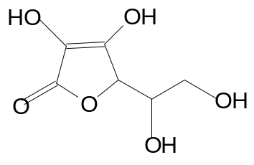  Which one of the following statements about vitamin C is incorrect?
 | A |  |  | Vitamin C cannot exhibit geometric isomerism.
 | B |  |  | 1 mole of vitamin C reacts completely with 4 moles of Na metal to give 2 moles of H₂ gas.
 | C |  |  | It can react with 2,4-dinitrophenylhydrazine to give an orange precipitate.
 | D |  |  | It can react with hot sodium hydroxide.
Section B
For each of the questions in this section, one or more of the three numbered statements 1 to 3 may be correct.
Decide whether each of the statements is or is not correct (you may find it helpful to put a tick against the statements which you consider to be correct).
The responses A to D should be selected on the basis of
A | B | C | D
1, 2 and 3  are correct | 1 and 2  only are correct | 2 and 3  only are correct | 1 only is correct
No other combination of statements is used as a correct response.

26 |  | Which reactions cannot represent standard enthalpy changes at 298 K?
 |  | 1 |  |  | NH₃(g) + HCl(g) → NH₄Cl(s)
 |  | 2 |  |  | C(g) + 8H(g) → C₃H₈(g)
 |  | 3 |  |  | CH₄(g) + 2O₂(g) → CO₂(g) + 2H₂O(g)
27 |  | For which of the following reactions does the enthalpy value represent both a standard enthalpy change of combustion and a standard enthalpy change of formation?
 |  | 1 |  |  | C(s) + O₂(g) → CO₂(g)
 |  | 2 |  |  | 2C(s) + O₂(g) → 2CO(g)
 |  | 3 |  |  | C(s) + 2O(g) → CO₂(g)
28 |  | Consider the following changes:  ∆H₁: M(s) → M(g)  ∆H₂: M(s) → M²⁺(g) + 2e ⁻  ∆H₃: M(g) → M⁺(g) + e⁻  ∆H₄: M⁺(g) → M²⁺(g) + e⁻  ∆H₅: M(g) → M²⁺(g) + 2e ⁻  The second ionisation energy of M could be calculated from the energy values associated with
 |  | 1 |  |  | ∆H₁ + ∆H₅
 |  | 2 |  |  | ∆H₅ - ∆H₃
 |  | 3 |  |  | ∆H₂ - ∆H₁ - ∆H₃
29 |  | When a compound W was heated in the tube containing reagent X, a colour change was observed in the tube. A precipitate was noted when reagent Y was heated with the products from reaction of W and X. Which of the following combinations could be W, X and Y?
 |  |  |  |  | W X Y
 |  | 1 |  |  | CH₂=CH₂ aqueous bromine CH₃CO₂⁻Ag⁺
 |  | 2 |  |  | CH₂=CHCH₃ acidified KMnO₄(aq) Fehling’s solution
 |  | 3 |  |  | CH₃CH₂Br NaOH(aq) alkaline aqueous iodine
30 |  | The two compounds P and Q shown below are important flavours in citrus fruits. These compounds are commonly used in the food and perfume industries.  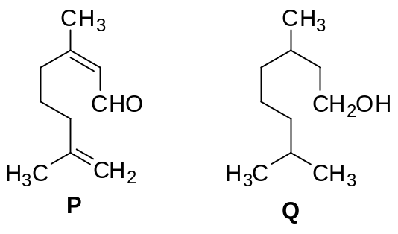
 |  | Which statements concerning P and Q are correct?
 |  | 1 |  |  | Q can be distinguished from P by using sodium metal.
 |  | 2 |  |  | P can be converted to Q using lithium aluminium hydride in dry ether.
 |  | 3 |  |  | Reaction of P with hot acidified KMnO₄ gives two organic products.

Answers
1 | D | 11 | A | 21 | B
2 | B | 12 | A | 22 | B
3 | D | 13 | B | 23 | C
4 | D | 14 | C | 24 | A
5 | A | 15 | A | 25 | C
6 | B | 16 | D | 26 | C
7 | D | 17 | A | 27 | D
8 | A | 18 | B | 28 | C
9 | C | 19 | D | 29 | D
10 | C | 20 | C | 30 | D

